Modern PC hardware components
- David Buck, January 2018

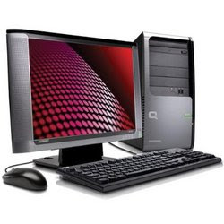
A modern computer consists of several visible components such as mouse, keyboard, system unit or case, and the LCD screen:

System Unit or Case
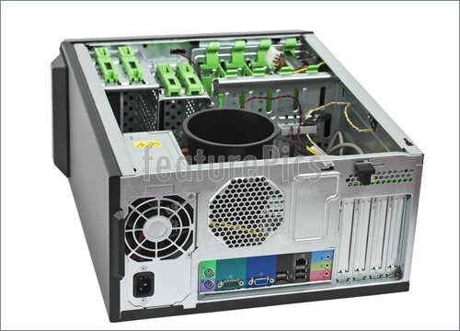
_______________________________________________________________________________
_______________________________________________________________________________
_______________________________________________________________________________
_______________________________________________________________________________
_______________________________________________________________________________

Mouse
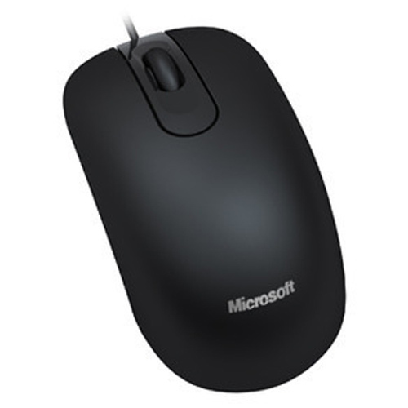
_______________________________________________________________________________
_______________________________________________________________________________
_______________________________________________________________________________
_______________________________________________________________________________
_______________________________________________________________________________

Keyboard
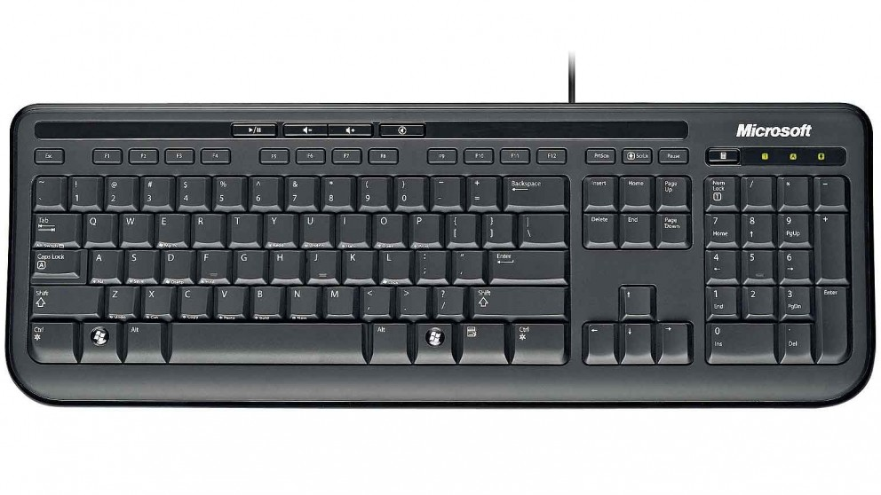
_______________________________________________________________________________
_______________________________________________________________________________
_______________________________________________________________________________
_______________________________________________________________________________
_______________________________________________________________________________

LCD Screen
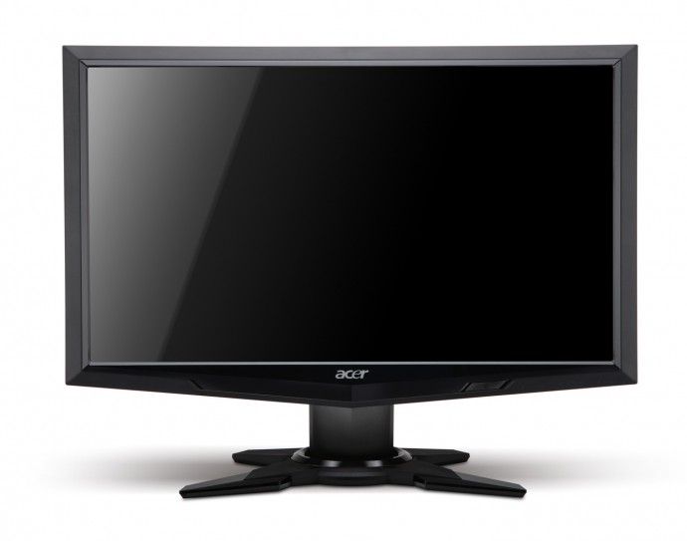
_______________________________________________________________________________
_______________________________________________________________________________
_______________________________________________________________________________
_______________________________________________________________________________
_______________________________________________________________________________

A computer system also consists of several internal hardware components as listed below:

Motherboard
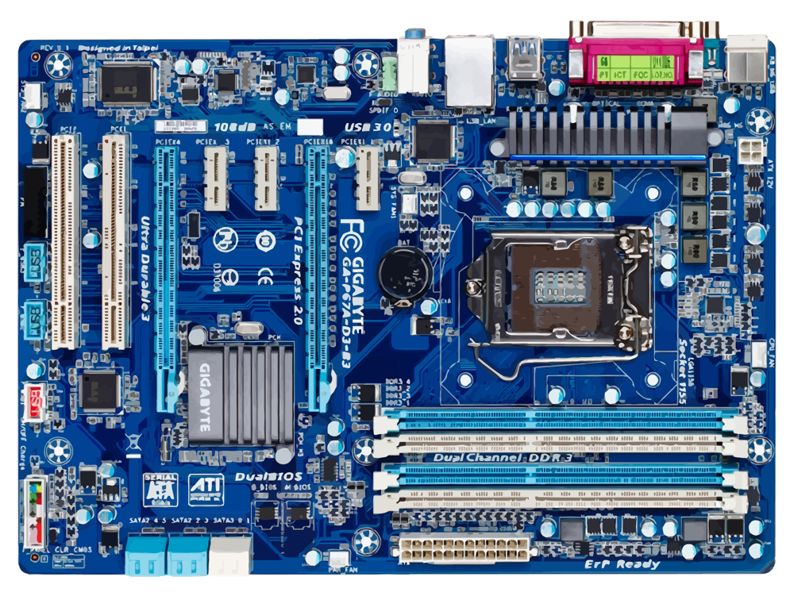
_______________________________________________________________________________
_______________________________________________________________________________
_______________________________________________________________________________
_______________________________________________________________________________
_______________________________________________________________________________
_______________________________________________________________________________
_______________________________________________________________________________
_______________________________________________________________________________
_______________________________________________________________________________
_______________________________________________________________________________
CPU or Processor
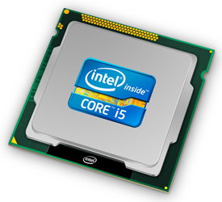
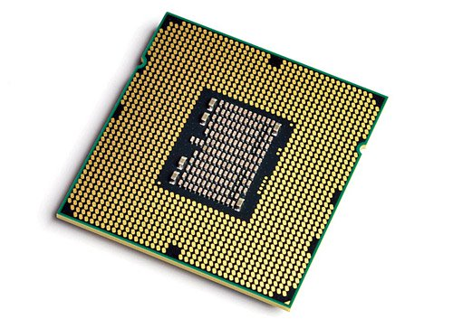
_______________________________________________________________________________
_______________________________________________________________________________
_______________________________________________________________________________
_______________________________________________________________________________
_______________________________________________________________________________

Memory or RAM
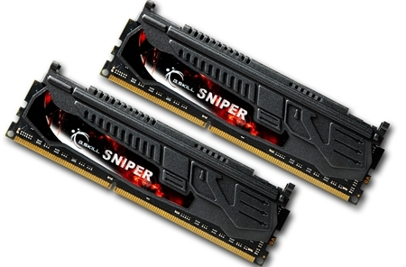
_______________________________________________________________________________
_______________________________________________________________________________
_______________________________________________________________________________
_______________________________________________________________________________
_______________________________________________________________________________

Graphics or VGA card

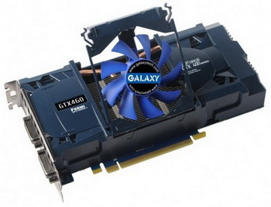

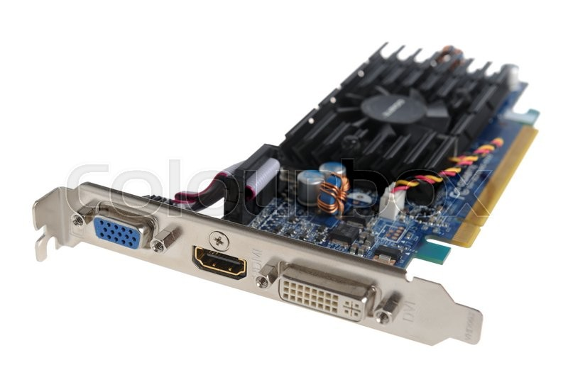
_______________________________________________________________________________
_______________________________________________________________________________
_______________________________________________________________________________
_______________________________________________________________________________
_______________________________________________________________________________

Hard Disk drive
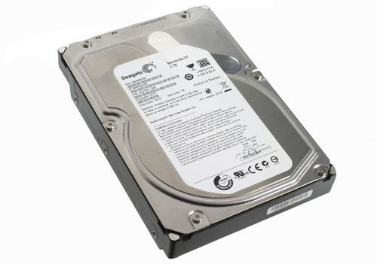

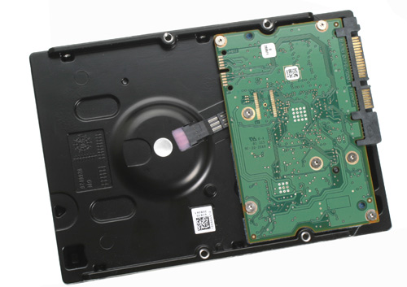

_______________________________________________________________________________
_______________________________________________________________________________
_______________________________________________________________________________
_______________________________________________________________________________
_______________________________________________________________________________

CD-ROM/ DVD drive

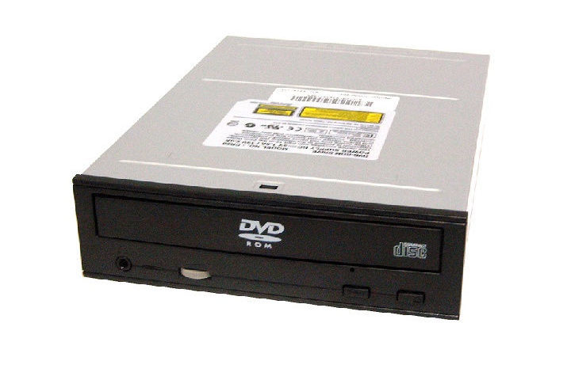

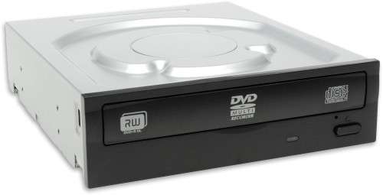

_______________________________________________________________________________
_______________________________________________________________________________
_______________________________________________________________________________
_______________________________________________________________________________
_______________________________________________________________________________

Case or Chassis
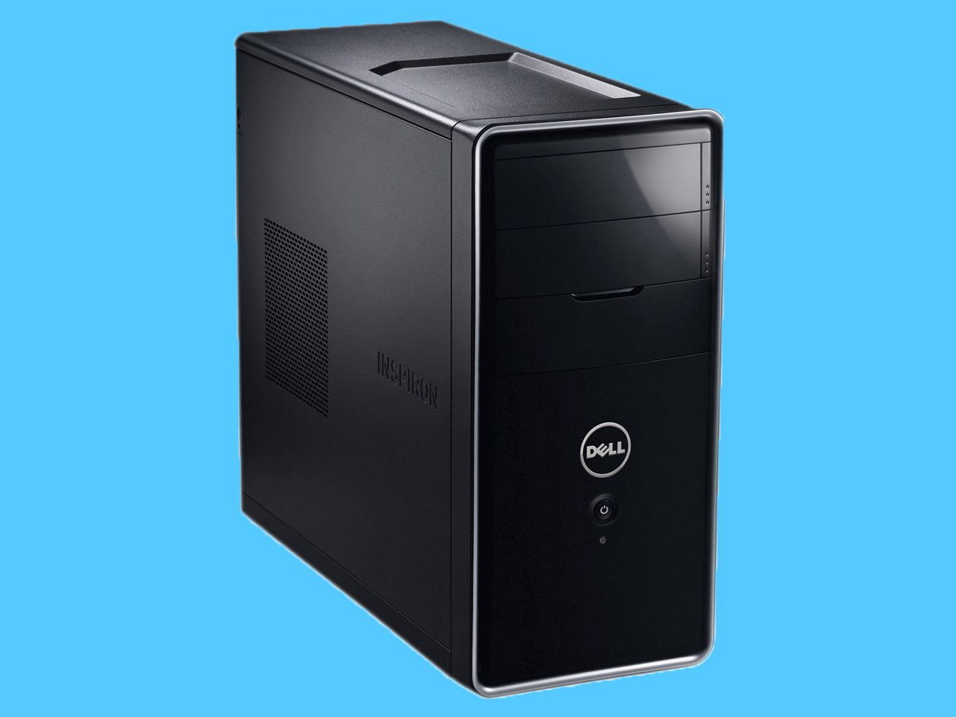

_______________________________________________________________________________
_______________________________________________________________________________
_______________________________________________________________________________
_______________________________________________________________________________
_______________________________________________________________________________

Power Supply
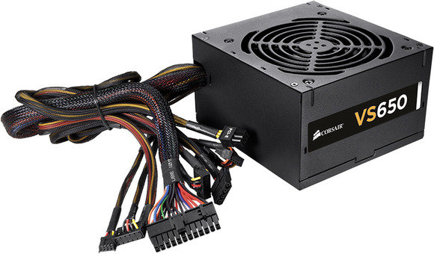

_______________________________________________________________________________
_______________________________________________________________________________
_______________________________________________________________________________
_______________________________________________________________________________
_______________________________________________________________________________

Cables
- This component will be discussed in a separate document.

Floppy drive
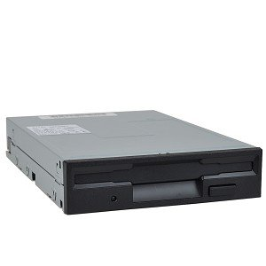

_______________________________________________________________________________
_______________________________________________________________________________
_______________________________________________________________________________
_______________________________________________________________________________
_______________________________________________________________________________

References:
Explaining computers – May 2017
http://www.explainingcomputers.com/hardware.html
How Motherboards work
https://computer.howstuffworks.com/motherboard1.htm
The best PC hardware you can buy – December 2017
https://www.pcworld.com/article/3112726/computers/the-best-pc-hardware-you-can-buy-today.html
